Training Manager: Requirements

# Overview

The Training Manager is a tool that supports us in managing internal trainings.

There are three groups of users

* Admin – creates and schedules trainings
* Trainer – manages own trainings
* Regular user – requests and participates in trainings

The major use-cases are depicted in the following diagram:

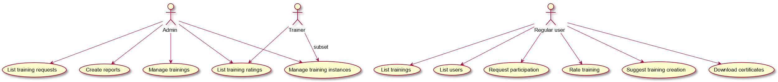

Each group comes with different interests and potentially different access privilege levels (e.g. new trainings can be added by an Admin user only, while generating a list of available trainings is allowed for every user). The user interface should be role-related and reduced to the necessary control elements and outputs.

To support a potentially large number of employees at different sites the tool should be accessible via network, e.g. as a web-based service. It should also deal well with concurrent access.

The system should encourage employees to take matters into their own hands instead of waiting for someone else to manage their knowledge. For example, the list of available trainings should be presented like items in a shop where clients can put the goods they want into a shopping cart and go to the checkout. Trainees should also be able to rate trainings they had.

# Terms and abbreviations

|  |  |
| --- | --- |
| **Term** | **Meaning** |
| Training | Description of a training course including documents, a list of suggested trainers, information about typical duration, etc.  For each training a list of languages exists. For each language a list of trainers exists. |
| Training instance | Specific instance of a training, with a list of participants, a date, etc. |

# Use-case description

## Manage trainings

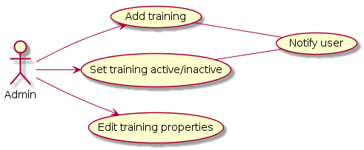

### Add training

Add a new training to the data base.

### Set training active/inactive

Mark training as active or inactive. Inactive trainings cannot be listed or requested by users. They stay in the data base for supporting integrity (references) and for being re-activated later.

### Edit training properties

Modify property values associated with a specific training, e.g. the maximum number of participants per instance.

### Notify user

Notify users about newly available trainings. Notifications are “fire and forget” items, the system doesn’t keep track of users having noticed them.

## Create Reports

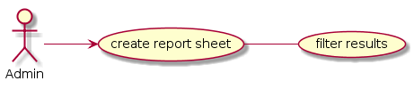

### Create report sheet

Create a HTML table or excel sheet as high level report.

### Filter results

Limit the results for various use-cases, e.g.

* Training being completed in a specific period
* Currently planned training
* Ratings
* Effort being invested in trainings
* ...

## Manage training instances

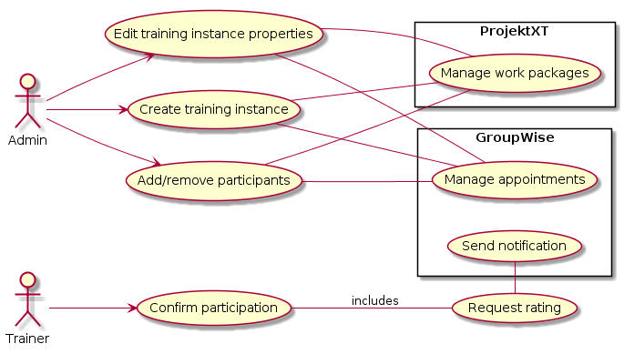

### Edit training instance properties

Modify property values associated with a specific training instance, e.g. the date.

### Manage work packages

Create or modify work packages inside ProjektXT, including

* Access rights for participants
* Start and end date according to training date
* Size according to number of participants and typical duration

Modifying the work package size manually inside ProjektXT should be possible, in other words: adding/removing participants should always apply a delta to the package size, not setting it to absolute values.

### Create training instance

Create a new training instance, in other words: a new date and set of participants.

### Add/remove participants

Add participants to an existing training instance or remove participants from an existing training instance.

### Manage appointments

Automated appointment creation inside GroupWise. Appointments should include all participants (e.g. not individual appointments per user) and the room or place the training is held.

The drawback of having the appointment resent in case the participant list changes is taken into account and considered smaller than the advantage of seeing who takes part without having to check this in the Training Manager.

### Send notification

Notify participant via E-Mail to rate a completed training (reminder). This should also serve as double-check to confirm participation (to uncover mistakes in the action “Confirm participation”).

### Request rating

Request participants to rate a completed training.

### Confirm participation

Trainer confirms participation and documents presence.

This is supplemented by the participant’s rating. The idea is to avoid problems like talking to an unspecified group in a telephone conference without knowing exactly who is present. By rating the training, the participant confirms participation.

## List training ratings

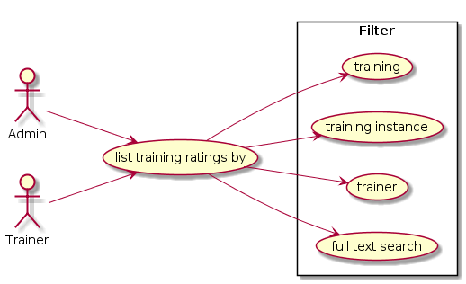

Review ratings of completed trainings.

The request list can be filtered by various attributes of the requests.

### Description of filters

Available filters might be restricted depending on the user role (data privacy).

|  |  |
| --- | --- |
| **Name** | **Use-case** |
| Training | For review of overall trainings. |
| Training instance | For specific instances of a training. |
| Trainer | For trainer to see what training he/she gives. |
| Full text search | Search for topics or catchwords. |

## List training requests

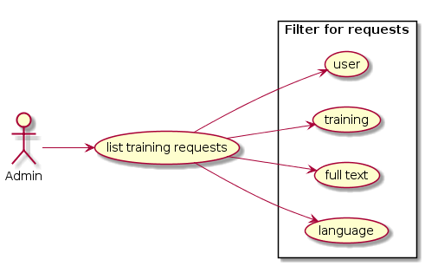

Generate a list of requests for being included in a training instance. The admin decides if participants can be added to an existing instance, or if a new instance needs to be created.

The request list can be filtered by various attributes of the requests.

## List trainings

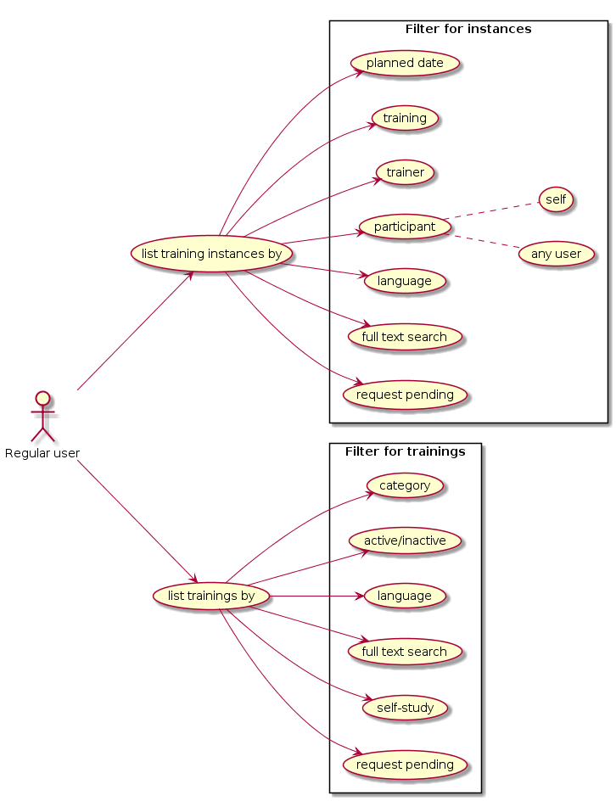

### List training instances

Generate a list of existing training instances. The list can be filtered by various attributes of the training instances.

### List trainings

Generate a list of offered trainings. The list can be filtered by various attributes of the trainings.

### Description of filters

Available filters might be restricted depending on the user role (data privacy).

|  |  |  |  |
| --- | --- | --- | --- |
| **Name** | **Training?** | **Instance?** | **Use-case** |
| Planned date |  | X | See what trainings are upcoming and what training have been finished. |
| Training |  | X | See what instances of a training exist |
| Trainer |  | X | For trainer to see what training he/she gives. |
| Participant |  | X | Self: see what trainings are planned for him/her Any user: see what trainings are planned for a specific user (privacy?) |
| Language | X | X | Filter for adequate languages only |
| Full text search | X | X | Search for topics or catchwords. |
| Request pending | X | X | See if participation was already requested for the user. |
| Category | X |  | See if there are other trainings in the same category which possibly also make sense to participate in |
| Active/inactive | X |  | For possible reactivating requests of past trainings. |
| Self-study | X |  | Find trainings that can be completed without any support. |

## List users

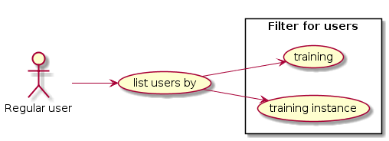

Generate a list of users that have participated in a training or specific instance of a training.

## Request participation

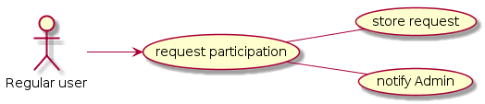

### Participation can be requested for trainings only, not for training instances. The information to collect is what trainings make sense based on the topic. Assigning to existing instances is a job for the Admin role.

### Store request

Store request in the data base.

### Notify Admin

Notification of the Admin that new requests exist.

## Rate training

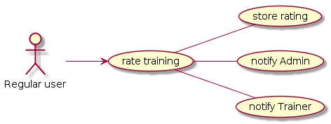

Ratings should contain an option for “did not participate”.

### Store rating

Store rating in the data base.

### Notify Admin

Notification of the Admin that the training has been rated.

### Notify Trainer

Notification of the Trainer that the training has been rated.

## Suggest training creation

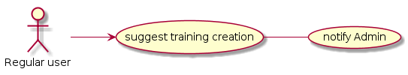

Suggest creation of a training for a specific topic. This should optionally include a proposal for a trainer. This satisfies two use-cases:

* A user wants to participate in a training that needs to be created
* A user wants to offer to give a training

### Notify Admin

Notification of the Admin that a user had a suggestion about a new training.

## Download certificates

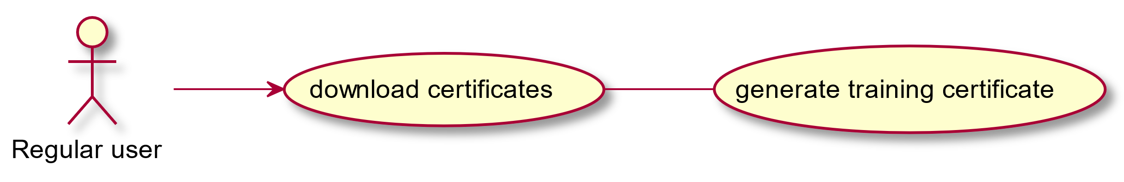

For trainings that have the certificate property set the user can generate and download such a certificate. There should be an option to control whether a training has its own certificate or generates an entry in a certificate item list (e.g. for a training that consists of a set of individual sessions with different subjects).

Certificates can be generated for trainings only if participation was confirmed from both sides.

## Event Notifications

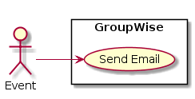

Any “notification” leads to an email sent to the recipient.

The subject line should be detailed enough to allow an intelligent filtering mechanism some inbox-magic.

# Backlog

* Datenbank anpassen auf Participation Request Storage

=> Todo: Datenbank Design

* Liste der Eigenschaften eines Trainings und einer Training Instance

# Random thoughts

* Externe Schulungen
* Bisher nur „Flag“ in der Schulung nötig, sonst keine großen/funktionalen Unterschiede auffindbar… nur für Filter / Grafische Darstellung von Belang
* Wiederkehrende Schulungen (z.B. Betriebshelfer)
* Benachrichtigungsmechanismus für Admin nach frei definierbaren Zeitraum
* Mehrfachtermine (z.B. C++-Schulung)
* Für jede eigene Serie eine Instanz anlegen
* Self-Study Flag vorsehen
* Heißt Min/Max Teilnehmer = 1 und andere Darstellung
* In Filter-Ansicht anzeigen ob Participation-Requests ausstehen:
* User: Flag hab ich einen Request ausstehen
* Admin: wieviel Requests gibt es
* Neues „Training“
* Am Zeitpunkt des Erstellens festgemacht, keine extra Flags…